**PART IV – ENTREPRENEURSHIP, REAL ESTATE, AND TRADE**

# 6. ENTREPRENEURSHIP

***Entrepreneurship deals with Business Register and Kafalat monthly statistics***

**Business register**

There are 9,370 establishments registered in the Business Register in 2010 in Lebanon. The peak is registered in March (10.7%).

**Table 6.1 – New establishments by Mohafazat. Number in 2010**

|  |  |  |  |  |
| --- | --- | --- | --- | --- |
| **Establishment** | **Number** | **%** | **Peak month. Number** | **Peak month. %** |
| **Lebanon** | **9,370** | **100** | **March (998)** | **March (10.7)** |
| **Mohafazat** | **Number** | **%** | **Peak month. Number** | **Peak month. %** |
| Mount-Lebanon | 4,601 | 49.1 | June (473) | June (10.3) |
| Beirut | 2,392 | 25.5 | March (272) | March (11.4) |
| North Lebanon | 986 | 10.5 | March (114) | March (11.6) |
| Bekaa | 570 | 6.1 | March (65) | March (11.4) |
| South Lebanon | 555 | 5.9 | January (69) | January (12.4) |
| Nabatiyeh | 266 | 2.8 | January (33) | January (12.4) |

*Table made by CAS based on Business Register data (2010)*

**Graph 6.1 – New establishments by Mohafazat. % in 2010**



*Graph made by CAS based on Business Register data (2010)*

Over the 9,370 new establishments registered in the Business Register in 2010:

* Peak Mohafazat: Mount-Lebanon (49.1%).

**Table 6.2 – New establishments by legal form in 2010**

|  |  |  |  |  |
| --- | --- | --- | --- | --- |
| **Establishment** | **Number** | **%** | **Peak month. Number** | **Peak month. %** |
| **All legal forms** | **9,370** | **100** | **March (998)** | **March (10.7)** |
| **Legal form top 5** | **8,874** | **94.4** | **March (931)** | **March (10.5)** |
| Individual enterprise | 3,612 | 38.4 | March (371) | March (10.3) |
| Limited liability company | 3,177 | 33.8 | March (343) | March (10.8) |
| Limited company | 887 | 9.4 | March (95) | March (10.7) |
| Off shore | 847 | 9.0 | January (97) | January (11.5) |
| Limited liability partnership | 351 | 3.7 | January and June (38) | January and June (10.8) |

*Table made by CAS based on Business Register data (2010)*

Over the 9,370 new establishments registered in the Business Register in 2010:

* + Peak establishment: Individual enterprise (38.4%).

**Table 6.3 – New establishments by type of activity. Number in 2010**

|  |  |  |  |  |
| --- | --- | --- | --- | --- |
| **Establishment** | **Number** | **%** | **Peak month. Number** | **Peak month. %** |
| **All legal forms** | **9,370** | **100** | **March (998)** | **March (10.7)** |
| **Type of activity top 5** | **5,825** | **62.0** | **January (643)** | **January (11.0)** |
| Other retail trades in a specialized store | 2,130 | 22.7 | April (243) | April (11.4) |
| Miscellaneous activities | 1,264 | 13.4 | March (175) | March (13.8) |
| Financial intermediation, insurance | 1,171 | 12.5 | January (139) | January (11.9) |
| Real-estate activities | 684 | 7.3 | January (70) | January (10.2) |
| Trade and auto repair | 576 | 6.1 | January (68) | January (11.8) |

*Table made by CAS based on Business Register data (2010)*

Over the 89,370 new establishments registered in the Business Register in 2010:

* + Peak establishment: Other retail trades in a specialized store: 22.7%

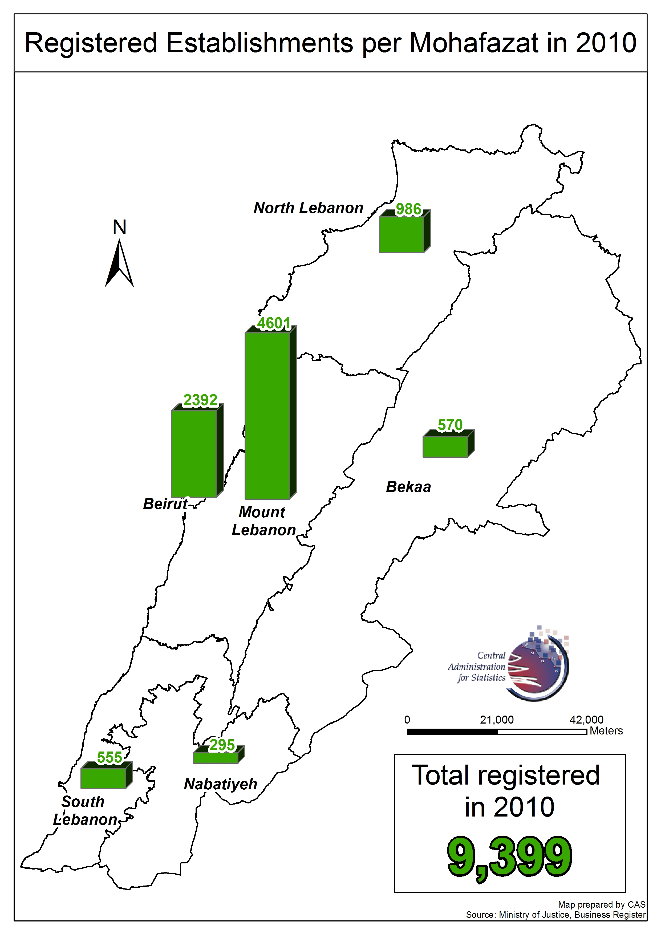

**Entrepreneurship: Kafalat activity**

Kafalat granted 1,353 guarantees to entrepreneurs in 2009. February (10.7%) is the peak month.

**Table 6.4 – Monthly Kafalat guarantees in 2010**

|  |  |  |  |  |  |  |  |  |  |  |  |  |  |  |
| --- | --- | --- | --- | --- | --- | --- | --- | --- | --- | --- | --- | --- | --- | --- |
| **Kafalat** | **Jan.** | **Feb.** | **March** | **April** | **May** | **June** | **July** | **Aug.** | **Sep.** | **Oct.** | **Nov.** | **Dec.** | **Total 2010** | **General %** |
| Basic | 114 | 122 | 99 | 94 | 71 | 104 | 75 | 82 | 70 | 81 | 66 | 70 | **1,048** | **77.5** |
| Plus | 25 | 22 | 41 | 16 | 25 | 23 | 16 | 24 | 27 | 22 | 33 | 22 | **296** | **21.9** |
| Innovation | 0 | 1 | 1 | 0 | 0 | 0 | 0 | 0 | 2 | 2 | 1 | 2 | **9** | **0.7** |
| **Total** | **139** | **145** | **141** | **110** | **96** | **127** | **91** | **106** | **99** | **105** | **100** | **94** | **1,353** | **100.0** |

*Table made by CAS based on Kafalat data (2010)*

Total value of credit is 171,366 million LBP. May (12.0%) and Kafalat Basic (65.7%) are the peaks.

***Table 6.5 – Monthly Kafalat guarantees. Million LBP in 2010***

|  |  |  |  |  |  |  |  |  |  |  |  |  |  |  |
| --- | --- | --- | --- | --- | --- | --- | --- | --- | --- | --- | --- | --- | --- | --- |
| **Kafalat** | **Jan.** | **Feb.** | **March** | **April** | **May** | **June** | **July** | **Aug.** | **Sep.** | **Oct.** | **Nov.** | **Dec.** | **Total 2010** | **General %** |
| Basic | 16,782 | 12,436 | 16,188 | 14,836 | 12,570 | 17,387 | 13,175 | 13,110 | 10,936 | 15,400 | 17,612 | 13,604 | **174,036** | **68.7%** |
| Plus | 7,140 | 5,732 | 10,473 | 4,640 | 6,431 | 5,612 | 5,784 | 6,258 | 5,411 | 5,334 | 8,644 | 5,805 | **77,264** | **30.5%** |
| Innovation | 0 | 300 | 150 | 0 | 0 | 0 | 0 | 0 | 196 | 435 | 300 | 480 | **1,861** | **0.7%** |
| **Total** | **23,922** | **18,468** | **26,811** | **19,476** | **19,001** | **22,999** | **18,959** | **19,368** | **16,543** | **21,169** | **26,556** | **19,889** | **253,161** | **100.0%** |

*Table made by CAS based on Kafalat data (2010)*

**Graph 6.2 – Kafalat guarantees by Mohafazat. % of approved contracts in 2010**



*Graph made by CAS based on Kafalat data (2010)*

The three types of guarantees are Basic, Plus and Innovation.

Over these 1,353 guarantees granted by Kafalat in 2010 by Mohafazat, Mount-Lebanon is the peak:

* + Percentage of granted guarantees: 44.9%.
  + Total amount: 124,258 million LBP (49.1% of the total amount of guarantees which is equal to 253,161 million LBP).

**Table 6.6 – Kafalat guarantees by Mohafazat in 2010**

|  |  |  |  |  |  |
| --- | --- | --- | --- | --- | --- |
| **Approved contracts** | **Basic** | **Plus** | **Innovation** | **Total** | **%** |
| Mount-Lebanon | 431 | 171 | 6 | **608** | **44.9%** |
| Bekaa | 215 | 17 | 0 | **232** | **17.1%** |
| North-Lebanon | 134 | 26 | 1 | **161** | **11.9%** |
| South-Lebanon | 132 | 14 | 1 | **147** | **10.9%** |
| Nabatiyeh | 100 | 6 | 0 | **106** | **7.8%** |
| Beirut | 36 | 62 | 1 | **99** | **7.3%** |
| **Lebanon** | **1,048** | **296** | **9** | **1,353** | **100** |

*Table made by CAS based on Kafalat data (2010)*

**Graph 6.3 – Kafalat guarantees by sector. % of approved contracts in 2010**

*Graph made by CAS based on Kafalat data (2010)*

Over the three types of the 1,360 Kafalat guarantees granted by sector in 2010, industry is the peak sector:

* Percentage of granted guarantees: 39.6%.
* Total amount: 302,164 million LBP (57.2% of the total amount of guarantees which is equal to 302,164 million LBP).

**Table 6.7 – Sectoral distribution of Kafalat guarantees. Number in 2010**

|  |  |  |  |  |  |
| --- | --- | --- | --- | --- | --- |
| **Approved contracts. Number** | **Basic** | **Plus** | **Innovation** | **Total** | **%** |
| Agriculture | 515 | 15 | 0 | **530** | **39.0%** |
| Industry | 391 | 145 | 2 | **538** | **39.6%** |
| Tourism | 118 | 118 | 0 | **236** | **17.4%** |
| Handicraft | 16 | 2 | 0 | **18** | **1.3%** |
| Specialized Techniques | 7 | 24 | 7 | **38** | **2.8%** |
| **Lebanon** | **1,047** | **304** | **9** | **1,360** | **100.0%** |

*Table made by CAS based on Kafalat data (2010)*

