5. ENERGY
Energy deals with Electricité du Liban activity, imports, tariffs, and wharehouse activity of petroleum products, and grographic distribution of hydrocarbon statistics.

Electricité du Liban in 2010

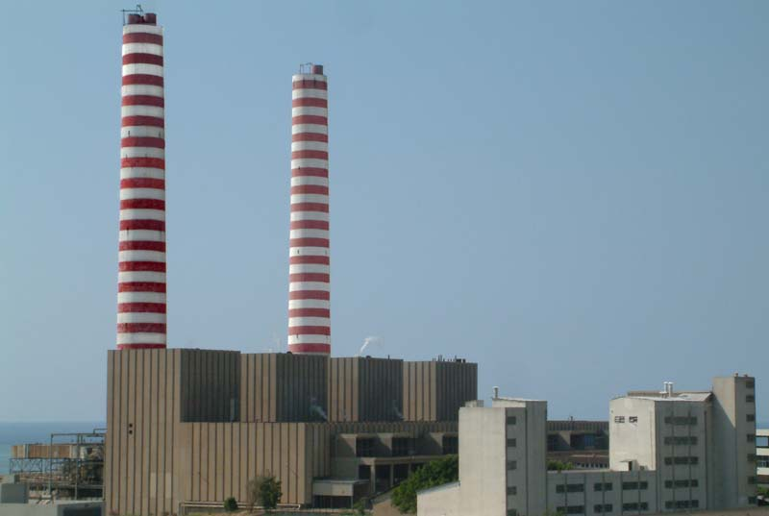
Source: http://www.edl.gov.lb/photogalery.htm
Energy production 10,486 million KWh:
- Thermal energy: 99.0%.
- Hydraulic energy: 1.0%.
Energy purchases are 1,557 million KWh:
- Thermal energy: 50.8%.
- Hydraulic energy: 49.2%.
Network energy consumption is 12,467 million KWh:
- Thermal energy: 93.2%.
- Hydraulic energy: 6.8%.

Table 5.1 – Energy production, purchases, and consumption. Million KWh in 2010
Energy | Million KWh | % | Peak month. Million KWh | Peak month. %
Production | 10,486 | 100.0 | August (1,084) | August ( 10.3)
Thermal | 10,378 | 99.1 | August (1,083) | August (10.4)
Hydraulic | 107 | 0.9 | November (35) | November (32.3)
Purchases | 1,557 | 100.0 | April (240) | April ( 15.4)
Thermal | 791 | 50.8 | November (154) | November (19.5)
Hydraulic | 766 | 49.2 | March (111) | March (14.4)
Network consumption | 12,467 | 100.0 | July (1,177) | July ( 9.4)
Thermal | 11,618 | 93.2 | July (1,134) | July (9.8)
Hydraulic | 849 | 6.8 | March (125) | March (14.7)
Table made by CAS based on Electricité du Liban data (2010)

Total hydraulic energy is 107 million KWh:
- Qadisha station production: 57.2%.
- Safa Station production: 42.8%.

Table 5.2 – Thermal energy production, purchases and consumption. Million KWh in 2010
Thermal energy | Million KWh | % | Peak month. Million KWh | Peak month. %
Total production | 10,378 | 100 | July (1,083) | August (10.4)
Mixed | 5,570 | 53.7 | July (563) | July (10.1%)
Steam | 4,060 | 39.1 | August (426) | August (10.5)
Gas | 485 | 4.7 | August (82) | August (16.9)
Qadisha | 264 | 2.5 | August (26) | August (9.9)
Network consumption | 12,467 | 100.0 | July (1,177) | July ( 9.4)
Mixed | 5,570 | 44.7 | July (563) | July (10.1)
Steam | 4,323 | 34.7 | August (452) | August (10.5)
From Syria | 791 | 6.3 | October (97) | October (12.3)
Gas | 485 | 3.9 | August (82) | August (16.9)
From Egypt | 448 | 3.6 | November (65) | November (14.5)
Table made by CAS based on Electricité du Liban data (2010)

EDL power stations produced 12,459 million KWh:
- Thermal energy: 83.3%.
- Hydraulic energy: 6.7%.
- Purchased from other countries: 10.0%.
Night average power is 17,922 MW:
- Thermal energy: 90.7%.
- Hydraulic energy: 9.3%.

Table 5.3 – Production of EDL power stations. Million KWh in 2010
Thermal energy | Million KWh | % | Peak month. Million KWh | Peak month. %
Total energy | 12,459 | 100 | July (1,176) | July (9.4)
Hydraulic energy | 839 | 6.7 | March (125) | March (14.9)
Litani | 666 | 79.3 | March (88) | March (13.3)
Thermal energy | 10,378 | 83.3 | August (1,083) | August (10.4)
Dair Ammar | 2,660 | 25.6 | July (290) | July (10.9)
Purchase from other countries | 1,241 | 10.0 | November (154) | November (12.4)
From Syria | 792 | 63.9 | October (97) | October (12.3)
Table made by CAS based on Electricité du Liban data (2010)

Imports of petroleum products

Petroleum products are of several types: liquid gas, unleaded petrol 98 and 95 Ooctane, kerosene for aircraft, imported oil by the private sector (Diesel oil), imported oil by the Ministry of Energy and Water for Electricité du Liban and for the local market (imported through the refineries of Tripoli and Zahrani), imported fuel-oil by the Ministry of Energy and Water for Electricité du Liban and asphalt.

Table 5.4 – Imports of oil products. Tonnes in 2010
Oil products | Tonnes | Peak month. Tonnes | Peak month. %
Ministry of Energy and Water (MEW) | 3,665,759 | May (778,464) | May (21.2)
Imported oil by the Ministry of Energy and Water for EDL | 1,524,288 | May (587,087) | May (38.5%)
Imported fuel-oil by the Ministry of Energy and Water for EDL | 1,283,360 | September (167,784) | September (13.1)
Imported oil by the Ministry of Energy and Water for the local market | 858,112 | January (119,401) | January (13.9)
Others | 5,441,241 | May (3,292,148) | May (60.5)
Imported oil by the private sector (Diesel oil) | 3,490,380 | May (3,171,304) | May (90.9)
Unleaded petrol 95 Octane | 1,067,351 | August (163,586) | August (15.3)
Unleaded petrol 98 Octane | 250,027 | December (36,776) | December (14.7)
Kerosene for aircraft | 230,950 | November (37,307) | November (16.2)
Imported fuel oil by the private sector | 199,724 | October (48,829) | October (24.4)
Liquid Gas | 117,975 | March (15,533) | March (13.2)
Asphalt (Bitumen) | 84,833 | April (16,158) | April (19.0)
Refineries of Tripoli and Zahrani | 887,891 | January (119,401) | January (13.4)
Gas-oil | 887,891 | January (119,401) | January (13.4)
Table made by CAS based on the Ministry of Energy and Water data (2010)

Tariffs of petroleum products

The Ministry of Energy and water publishes weekly tariffs of several petroleum products.

Table 5.5 – Tariffs of petroleum products in January and December. LBP and USD in 2010
Petroleum product | 2010
 | January price. LBP | December price. LBP | 2010 price change. %
Oil octane 98 in LBP | 31,700 | 35,700 | 12.6%
Oil octane 95 in LBP | 31,000 | 35,000 | 12.9%
Kerosene in LBP | 19,300 | 23,700 | 22.8%
Mazout in LBP | 16,300 | 24,000 | 47.2%
Deizel oil for vehicles in LBP | 19,500 | 24,500 | 25.6%
Fuel-oil. Kkiloliter in LBP | 494 | 520 | 5.3%
Fuel-oil. 1% sulfur in LBP | 501 | 543 | 8.4%
Liquid gas cylinder. 10 Kg in LBP | 15,900 | 19,600 | 23.3%
Liquid gas cylinder. 12 Kg in LBP | 19,300 | 23,900 | 23.8%
Liquid gas. Tonnes in USD | 904 | 1,149 | 27.1%
Propane. Tonnes in USD | 928 | 1,226 | 32.1%
Butane. Tonnes | 898 | 1,130 | 25.8%
Table made by CAS based on the Ministry of Energy and Water data (2010)

All the prices increase in 2010 as they follow the international petroleum products prices. Mazout price in LBP displayed the highest increase (47.2%).

