**PART VII – SOCIAL SERVICES**

# 19. EDUCATION

***The Centre de Recherche et de Développement Pédagogique provides CAS with education figures. Education deals with academic, vocational, and higher education***

**Academic education**

There are 2,882 schools in Lebanon during the academic year 2009/2010. 942,391 students study in these schools which recruit 89,994 people. 1.6% of these schools were established before 1925 and 37.4% since 1986. 47.4% are public schools, 12.8% are private free schools, 37.2% are private schools, and 2.6% are special schools for UNRWA.

***Students***

50.3% of the 942,391 students during the academic year 2009/2010 are females. 58.7% of these students are enrolled in french language schools and 41.3% in english language schools.

30.3% are enrolled in public schools, 13.5% in private free schools, 3.5% in special schools for UNRWA, and 52.8% in private schools.

**Graph 19.1 – School students in Lebanon. Percentage in 2009/2010**



*Graph made by CAS based on the Centre de Recherche et de Développement Pédagogique data (2009/2010)*

***Human resources***

The 2,882 schools recruit 89,994 people divided among employees (62.2%), contractuals (35.8%) and volunteers (2.0%).

**Table 19.1 – Teachers in academic schools. Mohafazat in 2009/2010**

|  |  |  |
| --- | --- | --- |
| **Mohafazat** | **Teachers' number** | **Teachers' percentage** |
| Mount-Lebanon - Beirut Suburbs | 20,727 | 23.0 |
| North Lebanon | 20,270 | 22.5 |
| Bekaa | 11,849 | 13.2 |
| Mount Lebanon excluding Beirut Suburbs | 11,823 | 13.1 |
| South Lebanon | 10,112 | 11.2 |
| Beirut | 8,874 | 9.9 |
| Nabatieh | 6,339 | 7.0 |
| **Total** | **89,994** | **100.0** |

*Table made by CAS based on the Centre de Recherche et de Développement Pédagogique data (2009/2010)*

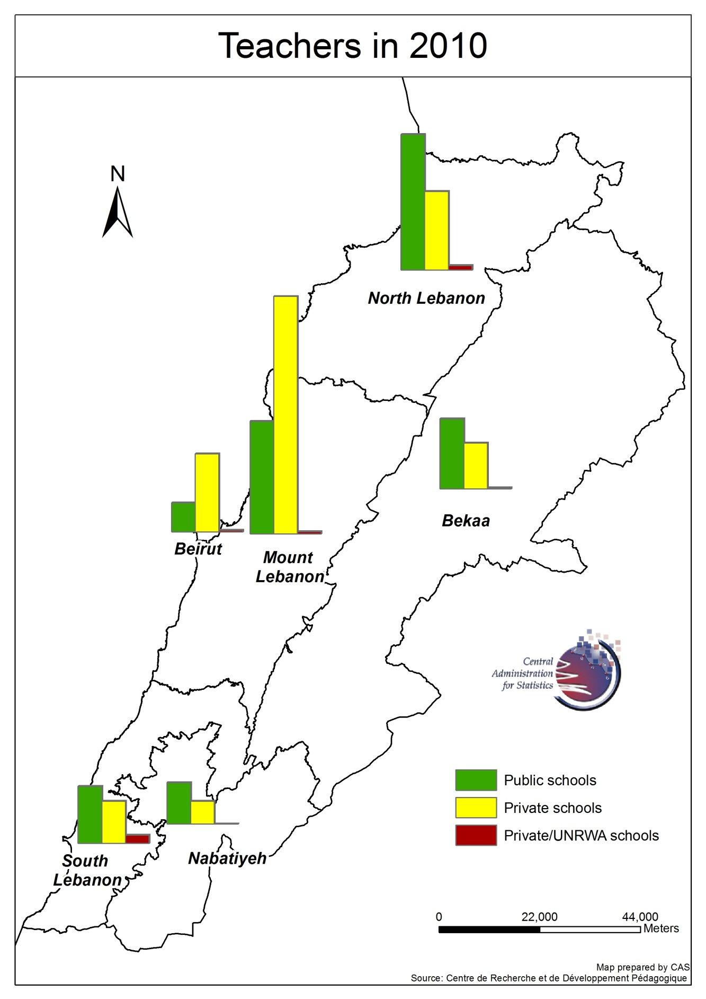

***Schools***

The 2,882 schools are pre-schools (2.8%), elementary (26.0%), intermediary (44.6%) and secondary schools (26.6%). 52.0% of the schools teach in French, 24.1% schools teach in English, and 23.9% in French and English.

**Vocational education**

Vocational education deals with human resources and students.

***Vocational education human resources***

Vocational education in the academic year 2009/2010:

* Total schools: 456 schools.
* Total human resources: 19,201 employees:
  + Females: 47.2% of total human resources.
  + Managers: 7.7% of total human resources.
  + Teachers: 92.3% of total human resources.

**Table 19.2 – Vocational education in Lebanon. Human resources in 2009/2010**

|  |  |  |  |  |  |
| --- | --- | --- | --- | --- | --- |
| **Vocational education** | **Schools. %** | **Human resources. %** | **Females. %** | **Managers. %** | **Teachers. %** |
| Public | 23.0 | 65.1 | 64.0 | 48.8 | 66.5 |
| Private | 77.0 | 34.9 | 36.0 | 51.2 | 33.5 |
| **Total. Number** | **456** | **19,201** | **9,066** | **1,473** | **17,728** |

*Table made by CAS based on the Centre de Recherche et de Développement Pédagogique data (2009/2010)*

***Public vocational education human resources***

In the academic year 2009/2010, 105 official vocational education schools recruit 11,783 teachers and 719 managers:

* Peak Mohafazat:
  + Schools: North Lebanon (24.8% of schools).
  + Human resources: North Lebanon (31.0% of human resources):
    - Managers: North Lebanon (29.5% of managers).
    - Teachers: North Lebanon (31.1% of teachers).
* Females: 46.4% of total human resources.

**Graph 19.1 – Public vocational schools human resources by Mohafazat. % in 2009/2010**



*Graph made by CAS based on the Centre de Recherche et de Développement Pédagogique data (2009/2010)*

***Private vocational education human resources***

In the academic year 2009/2010, 351 private vocational education schools recruit 5,945 teachers and 754 managers:

* Peak Mohafazat:
  + Schools: Mount-Lebanon - Beirut Suburbs (37.6% of schools).
  + Human resources: Mount-Lebanon - Beirut Suburbs (40.4% of human resources):
    - Managers: Mount-Lebanon - Beirut Suburbs (43.0% of managers).
    - Teachers: Mount-Lebanon - Beirut Suburbs (40.1% of teachers).
* Females: 48.7% of total human resources.

**Graph 19.2 – Private vocational schools human resources by Mohafazat. % in 2009/2010**



*Graph made by CAS based on the Centre de Recherche et de Développement Pédagogique data (2009/2010)*

**Vocational education students**

In the academic year 2009/2010, there are 95,811 vocational education students:

* Females: 47.5% of students.
* Official diplomas: 38.9% of total students.
* Other private diplomas: 61.1% of total students.

**Table 19.3 – Vocational education in Lebanon. Students in 2009/2010**

|  |  |  |  |
| --- | --- | --- | --- |
| **Vocational education** | **Public. %** | **Private. %** | **Total. Number** |
| Aptitude | 0.3 | 0.6 | 470 |
| Intermediate | 12.7 | 9.1 | 10,079 |
| Secondary | 3.2 | 0.2 | 1,351 |
| Technical Baccalaureate. | 50.8 | 44.2 | 44,813 |
| TS | 28.9 | 14.9 | 19,488 |
| Technical diploma | 4.0 | 0.0 | 1,500 |
| Teaching diploma | 0.0 | 0.0 | 0 |
| LT | 0.0 | 0.9 | 507 |
| **Total of official diplomas** | **100.0** | 69.9 | **78,208** |
| Private certificates for 3 months | 0.0 | 8.4 | 4,942 |
| Private certificates for 1 year | 0.0 | 21.6 | 12,661 |
| **Total students. Number** | **37,317** | **58,494** | **95,811** |

*Table made by CAS based on the Centre de Recherche et de Développement Pédagogique data (2009/2010)*

***Public vocational education students***

In the academic year 2009/2010, 37,317 students in public schools obtained official diplomas:

* Peaks:
  + North-Lebanon: 27.6% of total students.
  + Technical Baccalaureate: 50.8% of total students
* Females: 48.3% of total students.

**Graph 19.3 – Public vocational schools students by Mohafazat. % in 2009/2010**



*Graph made by CAS based on the Centre de Recherche et de Développement Pédagogique data (2009/2010)*

***Private vocational education students***

In the academic year 2009/2010, 58,494 students enrolled in private schools obtained diplomas:

* Peaks:
  + Mount-Lebanon and Beirut suburbs: 42.2% of total students.
  + Among official diplomas: Technical Baccalaureate: 63.2% of total students.
  + Among all diplomas: Technical Baccalaureate: 44.2% of total students.
* Statistics by sex:
  + Among official diplomas: Females: 44.5% of total students.
  + Among all diplomas: Females: 47.0% of total students.

**Graph 19.4 – Private vocational schools students by Mohafazat. % in 2009/2010**



*Graph made by CAS based on the Centre de Recherche et de Développement Pédagogique data (2009/2010)*

**Higher education**

In 2010, 180,850 students enrolled in universities operating in Lebanon:

* Females: 53.2% of total students.
* Nationality statistics: Foreigners: 16.2% of total students.

In 2010, 22,213 human resources worked in universities operating in Lebanon:

* Managers: 26.2% of total human resources.
* Teachers: 73.8% of total human resources.
* Females: 40.4% of total human resources.

In 2010, 5,826 managers worked in universities operating in Lebanon:

* Females: 49.9% of total managers.

In 2010, 16,387 teachers taught in universities operating in Lebanon:

* Females: 37.0% of total teachers.

**Table 19.4 – Higher education in Lebanon. Top eight universities in 2009/2010**

|  |  |  |  |  |  |  |
| --- | --- | --- | --- | --- | --- | --- |
| **University** | **Students** | **University students / Total students. %** | **Managers** | **University managers / Total managers. %** | **Teachers** | **University teachers / Total teachers. %** |
| Lebanese University | 72,813 | 40.3 | 1,893 | 32.5 | 5,226 | 31.9 |
| Beirut Arab University | 16,124 | 8.9 | 543 | 9.3 | 666 | 4.1 |
| Lebanese International Univerity | 13,706 | 7.6 | 539 | 9.3 | 973 | 5.9 |
| Université Saint-Joseph | 9,331 | 5.2 | 516 | 8.9 | 1,901 | 11.6 |
| American University of Beirut | 7,523 | 4.2 | 412 | 7.1 | 1,049 | 6.4 |
| Université Saint-Esprit Kaslik | 6,805 | 3.8 | 92 | 1.6 | 954 | 5.8 |
| Notre Dame University | 5,699 | 3.2 | 36 | 0.6 | 596 | 3.6 |
| Islamic University of Lebanon | 5,546 | 3.1 | 42 | 0.7 | 499 | 3.0 |
| **Total top eight universities** | 137,547 | 76.1 |  | 0.0 |  | 0.0% |
| **Total** | 180,850 | 100.0 | 5,826 | 100.0 | 16,387 | 100.0 |

*Table made by CAS based on the Centre de Recherche et de Développement Pédagogique data (2009/2010)*

**Education in Lebanon**

Finally, we sketch a general dashboard of education in Lebanon for the academic year 2009/2010.

**Table 19.5 – General education dashboard in Lebanon in 2009/2010**

|  |  |  |  |  |
| --- | --- | --- | --- | --- |
| **Type of establishment** | **Establishments** | **Students** | **Teachers** | **Managers** |
| **Academic education** | | | | |
| Public schools | 1,365 | 285,399 | 38,723 |  |
| Private schools | 1,517 | 656,992 | 51,271 |  |
| **Total academic education** | 2,882 | 942,391 | 89,994 |  |
| **Vocational education** | | | | |
| Public schools | 105 | 37,317 | 11,783 | 719 |
| Private schools | 351 | 58,494 | 5,945 | 754 |
| **Total vocational education** | 456 | 95,811 | 17,728 | 1,473 |
| **Higher education** | | | | |
| Public universities | 1 | 72,813 | 5,226 | 1,893 |
| Private universities | 37 | 108,037 | 11,161 | 3,933 |
| **Total higher education** | 38 | 180,850 | 16,387 | 5,826 |

*Table made by CAS based on the Centre de Recherche et de Développement Pédagogique data (2009/2010)*