# 10. TOURISM

***"Tourism is a social, cultural and economic phenomenon related to the movement of people to places outside their usual place of residence, pleasure being the usual motivation" (UNWTO, 2008, p. 1).***

***There are several forms of tourism:***

***"Domestic tourism: activities of a resident visitor within the country of reference either as a part of domestic trip or part of an outbound trip.***

***"Inbound tourism: activities of a non-resident visitor within the country of reference on an inbound trip".***

***"Outbound tourism: activities of a resident visitor outside the country of reference, either as a part of an outbound trip or as a part of domestic trip".***

***"Internal tourism = domestic tourism + inbound tourism".***

***"National tourism = domestic tourism + outbound tourism".***

***"International tourism = inbound tourism + outbound tourism" (UNWTO, pp. 16-17).***

***Source: UN World Tourism Organization (UNWTO) (2009), International Recommendations for Tourism Statistics, New York, 139 p.***

Tourism is a phenomenon with supply and demand sides and it generates employment.

**Tourism supply statistics**

***Tourism supply statistics deal with occupancy.***

***Occupancy – Incomings to Lebanon***

9,666,459people arrived to Lebanon in 2010 of whom:

* 45,008 people having work permits for the first time.
* 114,762 people renewing their work permits.
* 7,121disembarked tourists in Port of Beirut.
* Peak of arrivals is in July (11.7%) for Arab countries (86.8%).

**Table 10.1 – Incomings**

|  |  |  |  |
| --- | --- | --- | --- |
| **2010** | | | |
| **Top country** | **Incomings by continent** | | |
| **%** | **%** | **Number** | **Continent** |
| Syria (48.9) | 86.8 | 8,393,317 | All Arabs |
| France (25.4) | 5.7 | 549,481 | Europe |
| Iran (64.7) | 3.9 | 373,490 | Asia excluding Arab countries |
| United Sates (57.5) | 2.6 | 248,725 | America |
| Australia (96.2) | 0.6 | 60,433 | Oceania |
| Ethiopia (47.5) | 0.4 | 39,304 | Africa |
| Non-defined (44.7) | 0.0 | 1,709 | Extra States |
|  | **100.0** | **8,242,654** | **Total** |
|  | **1.7** | 159,770 | **Work permits** |

*Table made by CAS based on the General Directorate of General Security data (2010)*

**Graph 10.1 –Incomings by continent. % in 2010**

*Graph made by CAS based on General Directorate of General Security data (2010)*

Although departures do not constitute a part of tourism supply side – occupancy statistics, it is worthy to draw a graph regarding departures from Lebanon in 2010.

**Graph 10.2 – Outgoings by continent. % in 2010**



*Graph made by CAS based on General Directorate of General Security data (2010)*

**Table 10.2 – Outgoings**

|  |  |  |  |
| --- | --- | --- | --- |
| **2010** | | | |
| **Top country** | **Outgoings by continent** | | |
| **%** | **%** | **Number** | **Continent** |
| Syria (44.9) | 86.7 | 8,219,805 | Arab countries |
| Australia (96.2) | 5.8 | 549,179 | Oceania |
| United States (57.6) | 3.8 | 355,961 | America |
| Iran () | 2.6 | 249,725 | Asia |
| Ethiopia (52.4) | 0.6 | 60,961 | Africa |
| France (25.5) | 0.4 | 42,077 | Europe |
| Other Kuwait (43.1) | 0.0 | 1,195 | Extra States |
|  | **100.0** | **9,478,903** | **Total** |

*Table made by CAS based on the General Directorate of General Security data (2010)*

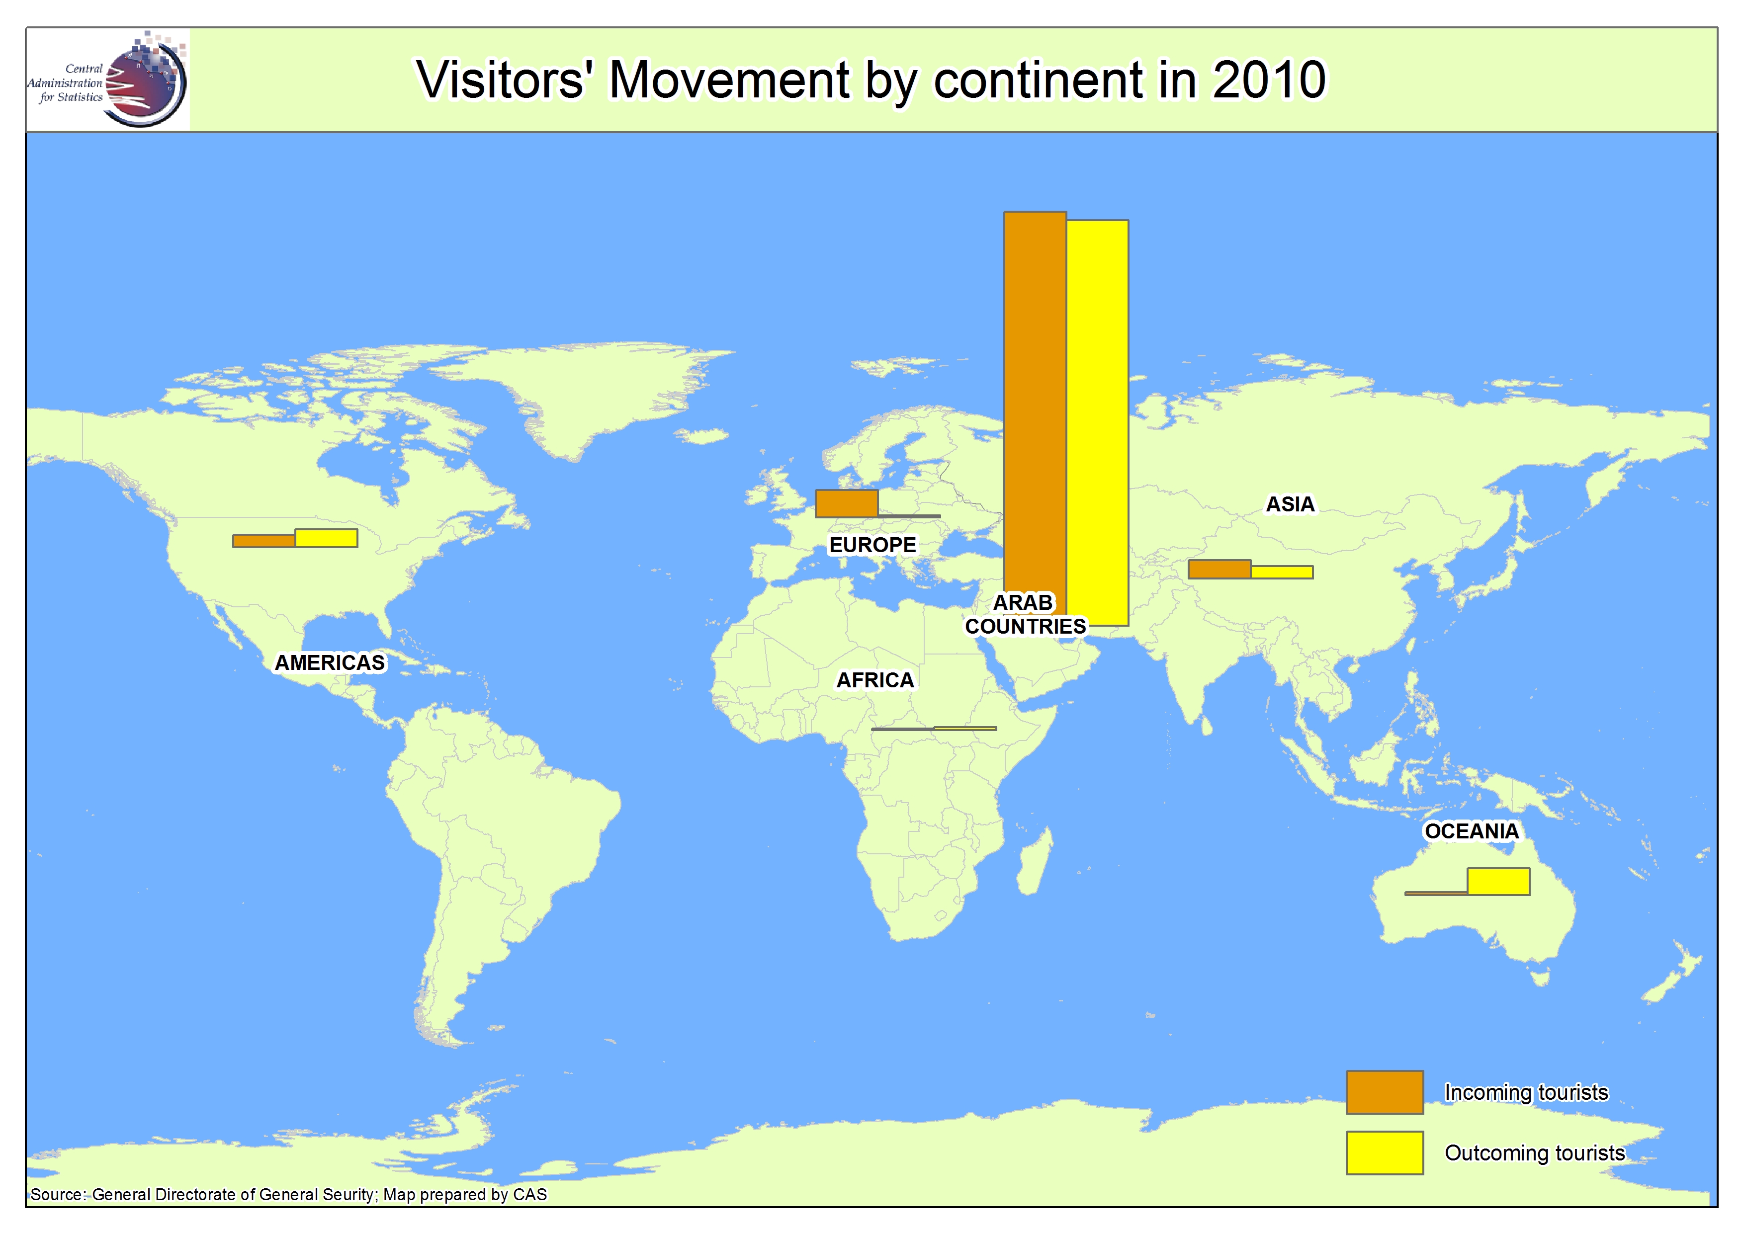

***Occupancy – Nights spent in accommodations***

877,909 clients went to accommodations (hotels and furnished apartments) where they spent 2,106,277 nights with an average of 2.4 nights per client.

**Table 10.3 – Accommodations clients and nights**

|  |  |  |  |  |
| --- | --- | --- | --- | --- |
| **2010** | | | | |
| **Top country. %** | | **Continent** | | |
| **Nights** | **Clients** | **Nights** | **Clients** | **Continent** |
| Lebanon (27.6) | Lebanon (27.7) | 1,374,271 | 619,477 | Arabs |
| France (18.1) | France (21.7) | 482,069 | 160,664 | Europe |
| United States (53.0) | United States (59.9) | 114,962 | 43,626 | America |
| Iran (37.6) | Iran (43.3) | 86,686 | 34,575 | Asia |
| Central Africa (31.1) | Central Africa (47.1) | 24,248 | 10,942 | Africa |
| Australia (74.0) | Australia (72.5) | 24,018 | 8,611 | Oceania |
| Antarctica  (100.0) | Antarctica (100.0) | 23 | 14 | Extra States |
|  |  | 2,106,277 | 877,909 | **Total** |

*Table made by CAS based on the Ministry of Tourism data (2010)*

**Graph 10.3 – Accommodations clients and nights by continent. % in 2010**



*Graph made by CAS based on General Directorate of General Security data (2010)*

The Ministry of Tourism survey for 2010 revealed that the amount spent in the hotel sector is 421,255,400 USD.

Investment in accommodation built 3 new hotels with 485 rooms and suites and 652 beds.

Two hotels were international in Beirut and one hotel was 3 stars in Mount-Lebanon.

**Tourism demand statistics: Tourist sites visitors**

943,318 persons visit 10 tourist sites in Lebanon in 2010:

* Peak nationality: Lebanese (20.3%).
* Peak tourist site: Jeita Grotto (45.4%).
* Peak month: July (16.5%)

**Table 10.4 – Tourist sites visitors excluding Jeita Grotto by continent**

|  |  |  |  |  |
| --- | --- | --- | --- | --- |
| **2010** | | | | |
| **Peak site visitors. %** | **Peak site visitors** | **Visitors. %** | **Visitors** | **Continent** |
| Baablbeck (35.3) | Baalbeck (92,703) | 61.6 | 262,889 | All Arabs |
| Byblos Citadel (33.1) | Byblos Citadel (34,413) | 24.3 | 122,998 | Europe |
| Byblos Citadel (34.7) | Byblos Citadel (6,682) | 4.5 | 19,240 | America |
| Byblos Citadel (42.8) | Byblos Citadel (7,156) | 3.9 | 16,718 | Asia excluding Arab countries |
| Baalbeck (55.6) | Baalbeck (2,401) |  | 4,322 | Oceania |
| National Museum (46.8) | National Museum (367) | 0.2 | 785 | Africa |
|  |  | **100.0** | **426,952** | **Total** |

*Table made by CAS based on the Ministry of Tourism and Ministry of Culture data (2010)*

67,484 students visited 4 tourist sites: Beiteddine Palace (42.8%), Byblos Citadelle (39.8%), Saida Citadelle (14.8%), and Tripoli (2.6%).

Regarding tourist sites tariffs, Jeita Grotto has the most expensive tariff for foreigners (LBP 18,150), while Faqra Grotto, Tebnine and Majdal Aanjar have the less expensive one (LBP 3,000).